Lighting Design Report: Level 3 Office Fit-Out
Design stage report, revision B. Calculations for maintained illuminance, uniformity and lighting power density.

1. Summary
This report sets out the lighting design for the Level 3 office fit-out (about 1,150 m2). All spaces meet the target maintained illuminance and uniformity with LED luminaires. The installed lighting power density is 5.6 W/m2 against a code allowance of 8.9 W/m2, a 37% margin.
- Open office: 532 lux average on the work plane, uniformity 0.64.
- Meeting rooms: 388 to 455 lux with separate presentation scene.
- All luminaires dimmable (DALI) with daylight sensors in the perimeter zone.
- Emergency lighting to 1 lux on escape routes, 3 hour duration.

2. Design criteria
Space | Target (lux) | Uniformity min. | UGR max. | Ra min.
Open office | 500 | 0.6 | 19 | 80
Meeting rooms | 400 | 0.6 | 19 | 80
Reception | 300 | 0.4 | 22 | 80
Corridors | 150 | 0.4 | 25 | 80
Break room | 200 | 0.4 | 22 | 80
Print room | 300 | 0.4 | 22 | 80

3. Calculation method
Calculations use a 0.25 m grid on a 0.75 m work plane, with reflectances of 70% (ceiling), 50% (walls) and 20% (floor). A maintenance factor of 0.80 is applied, based on a clean office, 3 year cleaning cycle and L80 lumen maintenance at 50,000 hours.
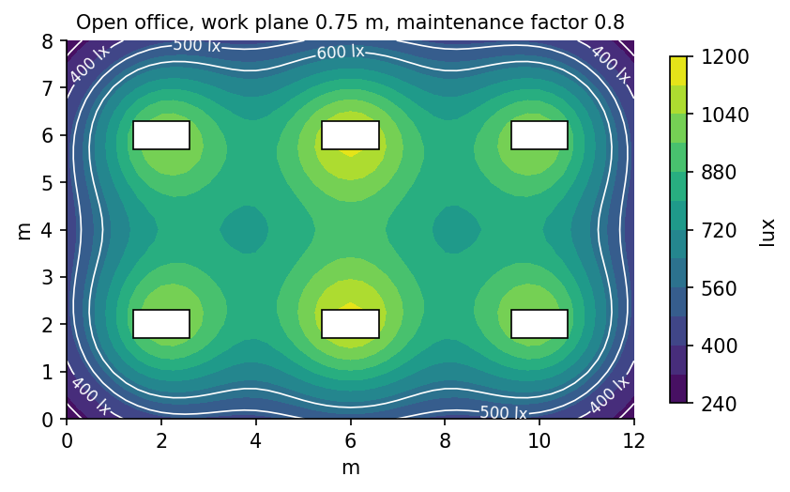
Figure 1. Open office isolux plot: six 600 x 1200 luminaires per bay.

4. Results
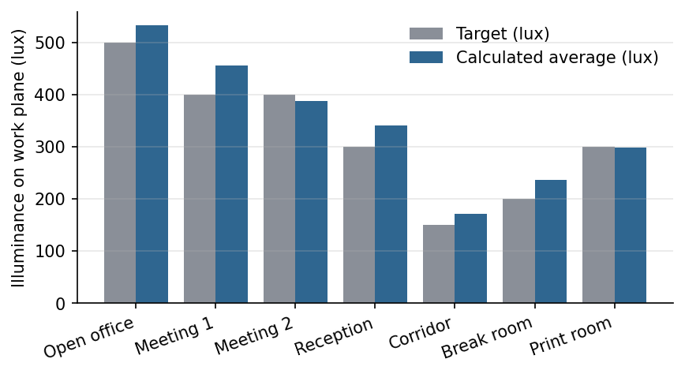
Figure 2. Target and calculated average illuminance by space.
Space | Area (m2) | Luminaires | Avg (lux) | Min/avg | W/m2
Open office | 640 | 96 | 532 | 0.64 | 5.9
Meeting 1 | 42 | 6 | 455 | 0.71 | 6.1
Meeting 2 | 36 | 4 | 388 | 0.66 | 4.8
Reception | 85 | 10 | 341 | 0.52 | 4.4
Corridor | 180 | 22 | 172 | 0.47 | 3.1
Break room | 95 | 9 | 236 | 0.58 | 3.9
Print room | 22 | 2 | 298 | 0.61 | 3.6

5. Controls
Each open-office bay is a DALI group with an occupancy sensor (15 minute hold) and a daylight sensor for the first 4.5 m from the facade. Meeting rooms have a four-button scene panel: Full, Presentation (front row at 20%), Video call (vertical illuminance on faces 250 lux) and Off.

6. Luminaire schedule
Type | Description | Lumens | Watts | CCT | Qty
L1 | Recessed panel 600 x 1200, opal | 4400 | 34 | 4000 K | 96
L2 | Recessed panel 600 x 600, opal | 3200 | 26 | 4000 K | 20
L3 | Downlight 150 dia., wide beam | 1800 | 15 | 3000 K | 34
L4 | Linear pendant, up/down | 5200 | 42 | 3500 K | 9
EM1 | Emergency bulkhead, 3 h | 300 | 3 | 5000 K | 18

7. Open items
- Confirm ceiling void depth above meeting rooms (duct clash, see RFI 014).
- Client to approve 3500 K for the break room pendants.
- Commissioning plan to be issued with the controls submittal.

